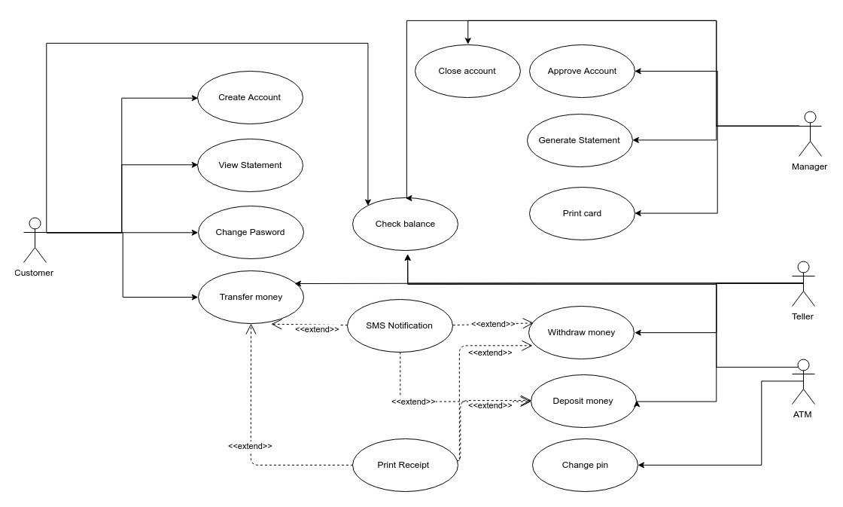  **Use Case Diagram for Smart banking system**

**Smart Banking System: Use Case Description**

|  |  |  |  |
| --- | --- | --- | --- |
| **Use case Number: 1** | | | |
| **Name** | | Teller CRUD | |
| **Brief description** | | This use case allows manager to create tellers. | |
| **Actors** | | Manager | |
|  | | | |
| **Preconditions: manager must have logged in to the system** | | | |
|  | | | |
| **Flows of events** | | | |
| 1. **Basic Flows** | | | |
| **1.1.0 Add Teller** | | | |
| Step | User Actions | | System Actions |
| 1 | The manager calls the create teller command. | | The system displays the teller creation form. |
| 2 | The manager fills out the form and request the system to save the details. | | The system verifies if there is no other teller with same social security number and returns a success message or a fail message in case of an exception. It should return a specific message when a duplicate teller exists |
| **Postconditions:** The teller is persisted in the system | | | |
|  | | | |
| **Business Rules:** Two tellers can’t have same social security number | | | |
|  | | | |
| **1.1.1 Read Teller** | | | |
| **step** | **User Actions** | | **System Action** |
| 1 | The manager selects to view a list of tellers | | The system returns a list of all tellers. |
| 2 | The manager selects to view a teller of one of the tellers from the list of tellers | | The system returns the information of the teller. |
| **1.1.1 Update Teller** | | | |
| **step** | **User Actions** | | **System Action** |
| 1 | The manager selects to view a list of tellers | | The system returns a list of all tellers. |
| 2 | The manager selects the teller he wants to update | | The system displays an editable teller form pre-populated with the teller details. |
| 3 | The manager updates the data of the teller they want to update and requests system to save the updated data. | | The system updates the record and returns the success message or a fail message on exception |
|  | | | |
| **Postconditions:** The teller details will be updated. | | | |
|  | | | |
| **1.1.3 Delete Teller** | | | |
| **step** | **User Actions** | | **System Action** |
| 1 | The manager selects to view a list of tellers | | The system returns a list of all tellers. |
| 2 | The manager selects the teller he wants to delete | | The system displays a confirmation dialogue window |
| 3 | The manager selects OK on the confirmation dialog window to confirm deleting the profile | | The system deletes the teller and returns message a success confirms. |
|  | | | |
| **Postconditions:** A teller will be deleted | | | |
|  |  | |  |

|  |  |  |  |
| --- | --- | --- | --- |
| **Use Case Number: 2** | | | |
| **Name:** | | Manager Operations | |
| **Brief description:** | | This use case provides manager functionality | |
| **Actors:** | | Manager | |
|  | | | |
| **Preconditions:** The Manager must logged in to the system | | | |
|  | | | |
| **Flows of Events:** | | | |
| **1. Basic Flows** | | | |
| **1.1.0 Approve Account** | | | |
| **Step** | **User Action** | | **System Action** |
| **1** | The Manager call view list of new customers waiting for approval | | The system displays list of new customers that are waiting for the manager’s approval |
| **2** | The Manger selects the customer and approve the account creation | | The system create a new account for the approved customer. |
| **Post-Condition:** The new customer account is added to the system database. | | | |
|  | | | |
| **Business Rules** | | | |
| No duplicate customer accounts. A unique account is identified by account number. | | | |
|  | | | |
| **1.1.1 Close Account** | | | |
| **Step** | **User Action** | | **System Action** |
| **1** | The Manager call view list of customers command | | The system displays list of customers. |
| **2** | The Manager selects the account which is needing to be closed | | The system deletes the selected account from the database. |
| **Post-Condition :** Customer account is deleted from the database. | | | |
|  | | | |
| 1.1.2 Generate Statement | | | |
| **Step** | **User Action** | | **System Action** |
| **1** | The Manager call generate customer reports command | | The system displays the field for statement generation |
| **2** | The Manager fills the required information for statement generation | | The system will generate customer’s statement. |
| **Post-Condition** | | | |
|  | | | |

|  |  |  |  |
| --- | --- | --- | --- |
| **Use case Number: 3** | | | |
| **Name** | | Create account | |
| **Brief description** | | This use case allows a customer to create an account which needs to be approved by the manager. | |
| **Actors** | | customer | |
|  | | | |
| **Preconditions:** Have a valid Social security number | | | |
|  | | | |
| **Flows of events** | | | |
| 1. **Basic Flows** | | | |
| **1.1.0 Create Account** | | | |
| Step | User Actions | | System Actions |
| 1 | The customer calls the create account command. | | The system displays the customer creation forms. |
| 2 | The customer fills out the form and request the system to send the details for manager approval. | | The system verifies if there is no other customer with this national ID/Passport number, name holding chosen account type in the database. The system generates a successful message on success or a fail message in case of failure. |
| **Postconditions:** The opened account is sent for approval to the manager. | | | |
|  | | | |
| **Business Rules:** | | | |
| No duplicate account type for one customer | | | |
| **1.1.1 view Account** | | | |
| **step** | **User Actions** | | **System Action** |
| 1 | The user clicks on view command | | The system returns a list of all tellers. |
| **1.1.2 Update Teller** | | | |
| **step** | **User Actions** | | **System Action** |
| 1 | The customer clicks on update | | The system displays an editable form pre-populated with his data |
| 2 | The customer updates his data | | The system updates the record and returns the success message or a fail message on exception |
|  | | | |
| **Postconditions:** The customer details will be updated. | | | |
|  | | | |

|  |  |  |  |
| --- | --- | --- | --- |
| **Use case Number: 4** | | | |
| **Name** | | Check Balance | |
| **Brief description** | | This use case allows:  -customer to check his balance online or through ATM  -Teller to check balance for a specific customer | |
| **Actors** | | Customer, Teller, ATM | |
|  | | | |
| **Preconditions: The customer (via web app or ATM) and teller must have logged using their credentials.** | | | |
|  | | | |
| **Flows of events** | | | |
| 1. **Basic Flows** | | | |
| **1.1.0 Check balance** | | | |
| Step | User Actions | | System Actions |
| 1 | The customer/ teller /ATM calls the check balance command. | | The system displays all accounts linked to the customer. |
| 2 | The customer / teller/ATM chooses the account. | | The system displays the current balance of the chosen account. |
| **Postconditions:** | | | |
|  | | | |
| **Business Rules:** | | | |
|  | | | |

|  |  |  |  |
| --- | --- | --- | --- |
| **Use case Number: 5** | | | |
| **Name** | | Deposit Money | |
| **Brief description** | | This use case allows the tellers and customers through ATM machine to deposit money in the system | |
| **Actors** | | Teller, ATM machine | |
|  | | | |
| **Preconditions: Teller and customer through ATM machine must have logged in to the system** | | | |
|  | | | |
| **Flows of events** | | | |
| 1. **Basic Flows** | | | |
| **1.1.0 Deposit Money** | | | |
| Step | User Actions | | System Actions |
| 1 | The Teller and ATM machine calls the deposit money command. | | The system asks to which account type the deposit will be made. |
| 2 | The teller and customer select the account type from the list | | The system displays the deposit money form with the field the amount of money that is going to be deposited |
| 3. | The teller and customer fill the amount of money to be deposited | | The system deposits the money to the current balance in the account and returns confirmation message. |
|  |  | |  |
| **Postconditions:** The deposit amount of money is added to the current balance and persisted in the system | | | |
|  | | | |
| **Business Rules:** | | | |
|  | | | |

|  |  |  |  |
| --- | --- | --- | --- |
| **Use case Number: 6** | | | |
| **Name** | | Transfer Money | |
| **Brief description** | | This use case allows the teller and customers through ATM machine to transfer money in the system | |
| **Actors** | | Teller, ATM machine | |
|  | | | |
| **Preconditions: Teller and customer through ATM machine must have logged in to the system** | | | |
|  | | | |
| **Flows of events** | | | |
| 1. **Basic Flows** | | | |
| **1.1.0 Deposit Money** | | | |
| Step | User Actions | | System Actions |
| 1 | The Teller and ATM machine calls the transfer money command. | | The system asks to which account type the deposit will be made. |
| 2 | The teller and customer select the account type from the list | | The system displays the transfer money form with the field account id to which the money is going to transfer |
| 3. | The teller and customer fill the account id | | The system requests the amount of money to be transferred |
| 4. | The teller and customer fill the amount of money | | The system verifies that the customer has that amount of money in the account and transfer the money and returns confirmation message |
|  |  | |  |
| **Postconditions:** The transfer amount of money is deducted from the customer account and added to the transferred account | | | |
|  | | | |
| **Business Rules: Customer must have sufficient balance in his account** | | | |
|  | | | |